Digital Experience Lead

July 2026


Key information about the role | 

 |  | Digital Experience Lead
 |  | Business area:  Customer Channels
 |  | Reports to:  Head of Customer Digital Enablement |  |  |  | Leader of others:  Yes – Digital Apprentice
 |  | Contract type:  Agile Homeworking |  |  |  | Budget holder:  No
 |  | Car Allowance:  No |  |  |  | DBS check required:  No

 | About the role

Role purpose

The post holder will lead the day-to-day delivery, quality and continuous improvement of Yorkshire Housing’s customer-facing digital channels – the Customer App/Portal, customer-facing CRM case management, and the Knowledge Platform. This role turns agreed strategy and signed-off requirements into working, tested, measurable customer journeys.
The role owns product management of the portal, the review and rebuild of customer-facing CRM case management, knowledge article implementation and lifecycle management, and the reporting that evidences whether digital channels are actually working for customers. It also leads the communications and engagement activity that drives customer adoption of those channels.
This is a hands-on delivery role in a deliberately lean team. It provides delivery resilience for the digital programme, works to the customer experience standards and design principles set by the Head of Customer Digital Enablement, and line manages the Digital Apprentice.

Here’s some of the things you’ll be doing | 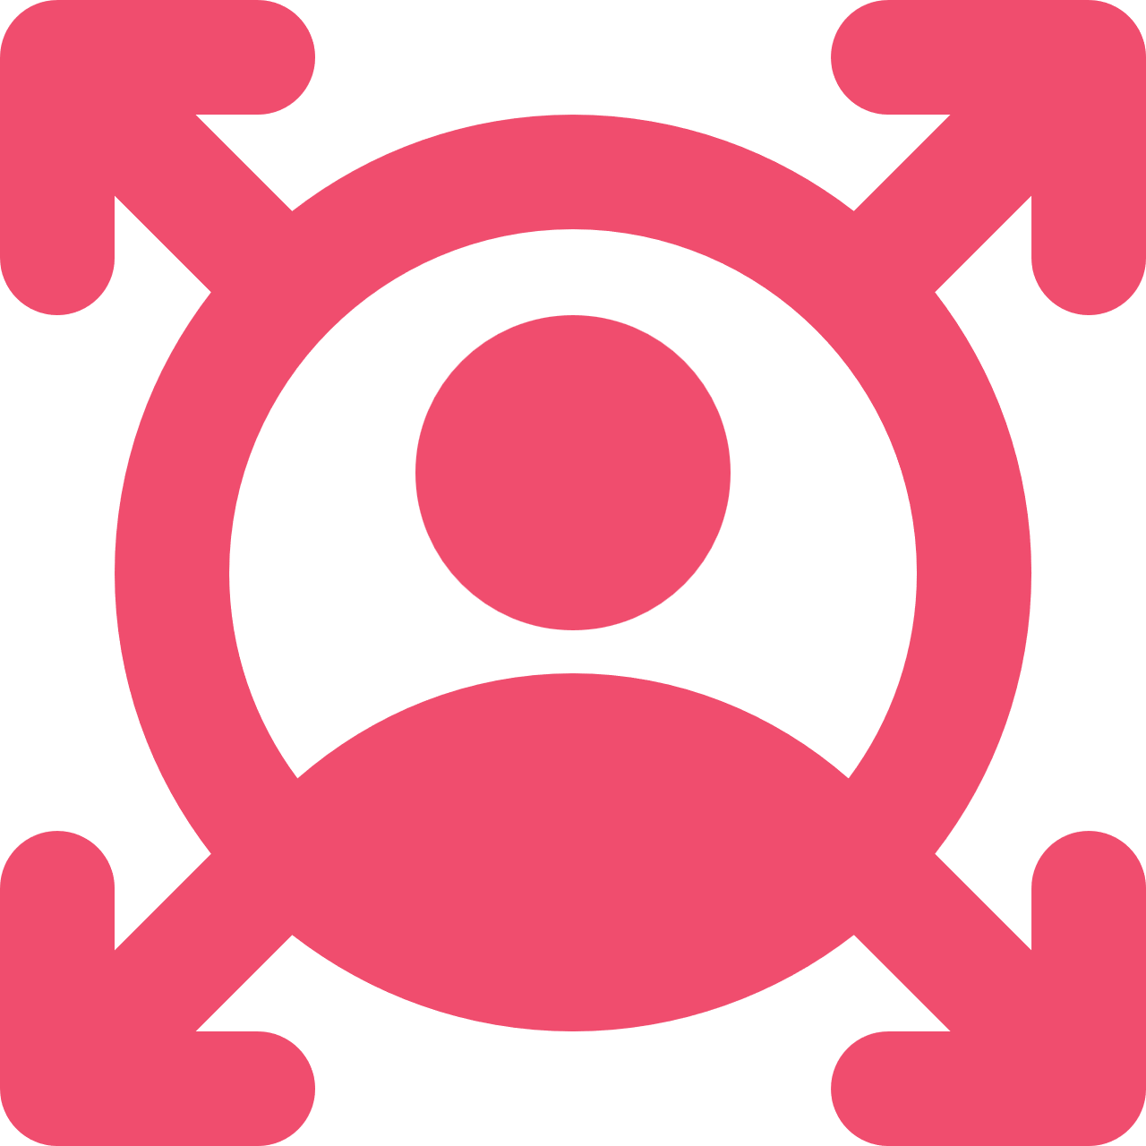

We’re Yorkshire by name and by nature. And we make it possible for people to have a place they’re proud to call home, whether that’s to rent or to buy. It’s our people that make that happen, and here’s how you’ll be supporting:

Key responsibilities:
Product and platform delivery
- Act as day-to-day Product Owner for the Customer App/Portal – managing the backlog, prioritising fixes and enhancements, planning releases and tracking delivery against agreed requirements
- Lead the portal improvement and defect resolution pipeline, maintaining a prioritised, visible and evidence-led fix list driven by customer impact rather than internal preference
- Act as the primary liaison with Salesforce CI and other technical delivery teams – translating signed-off requirements into delivery specifications, and coordinating build, UAT and release cycles
- Lead persona-based and unhappy-path testing on every customer-facing release, and hold the technical sign-off within the Customer Digital sign-off gate before go-live
- Own the digital channel release calendar, ensuring changes are planned, communicated and supported rather than landed on colleagues and customers unannounced
CRM case management and process design
- Lead the review, redesign and rebuild of customer-facing CRM case management – case types, categorisation, routing rules, data capture and service level standards – in partnership with Salesforce CI
- Design out structural points of failure in case handling, including misclassification at the point of capture, duplicate or orphaned routing, and queues with no owner or service standard
- Own customer-facing SOPs and process standards for digital channels, ensuring structured data is captured at the point of contact and is fit for reporting and future automation
- Ensure every customer-facing form, field and label is written in plain English and tested for meaning, not internal terminology
Knowledge Base implementation and article management
- Lead implementation and ongoing management of the Knowledge Platform for both customer-facing and colleague-facing content
- Own the article lifecycle end to end – authoring standards, SME nomination, technical review, sign-off register, scheduled review cycles and retirement of out-of-date content
- Own Knowledge Base configuration and publishing governance in Salesforce, including taxonomy, controlled keywords, access model and search performance
- Maintain the distinction between knowledge articles, training guides and SOPs, ensuring each content type is used for its intended purpose
- Monitor article usage, search failure and deflection performance, and act on the gaps
KPIs, reporting and insight
- Maintain the portal dashboard and reconcile behavioural data (Google Analytics) with transactional data (Salesforce), treating the gap between them as a friction indicator rather than a reporting error
- Collect and report benefit realisation data for digital channels, feeding the CX Measurement pillar reported by the Head of Customer Digital Enablement
- Turn reporting into a prioritised improvement backlog, so measurement drives action rather than describing it
- State data confidence clearly, flagging directional figures as directional and never presenting assumptions as confirmed fact
Communications and customer adoption
- Plan and deliver customer communications and campaigns that drive adoption of digital channels, working with Customer and Digital Communications
- Coordinate production of customer-facing guidance, help content and how-to material that supports customers to self-serve confidently first time
- Support delivery of targeted adoption interventions for digitally hesitant and lower digital literacy customers, designing for the least confident customers first
- Track adoption by segment and journey, identify where customers are dropping out, and act on it
- Support internal readiness for digital change, ensuring colleagues can guide customers to digital channels
Leadership and ways of working
- Line manage, coach and develop the Digital Apprentice, including formal workplace mentor responsibilities under apprenticeship framework requirements
- Own delivery tracking and RAG reporting across live digital workstreams, escalating blockers, dependencies and resourcing conflicts early
- Provide delivery resilience for the digital programme, ensuring progress does not stall when the Head of Customer Digital Enablement is focused on other priorities
- Deputise for the Head of Customer Digital Enablement in operational and delivery forums as required
- Work in the open – documenting decisions, design rationale and boundary issues in writing

 | As you can imagine, the above might not be all you’ll be responsible for in role so you might be asked to take on some other key responsibilities if they’re suitable for your role.

So, what will you bring to the role? | 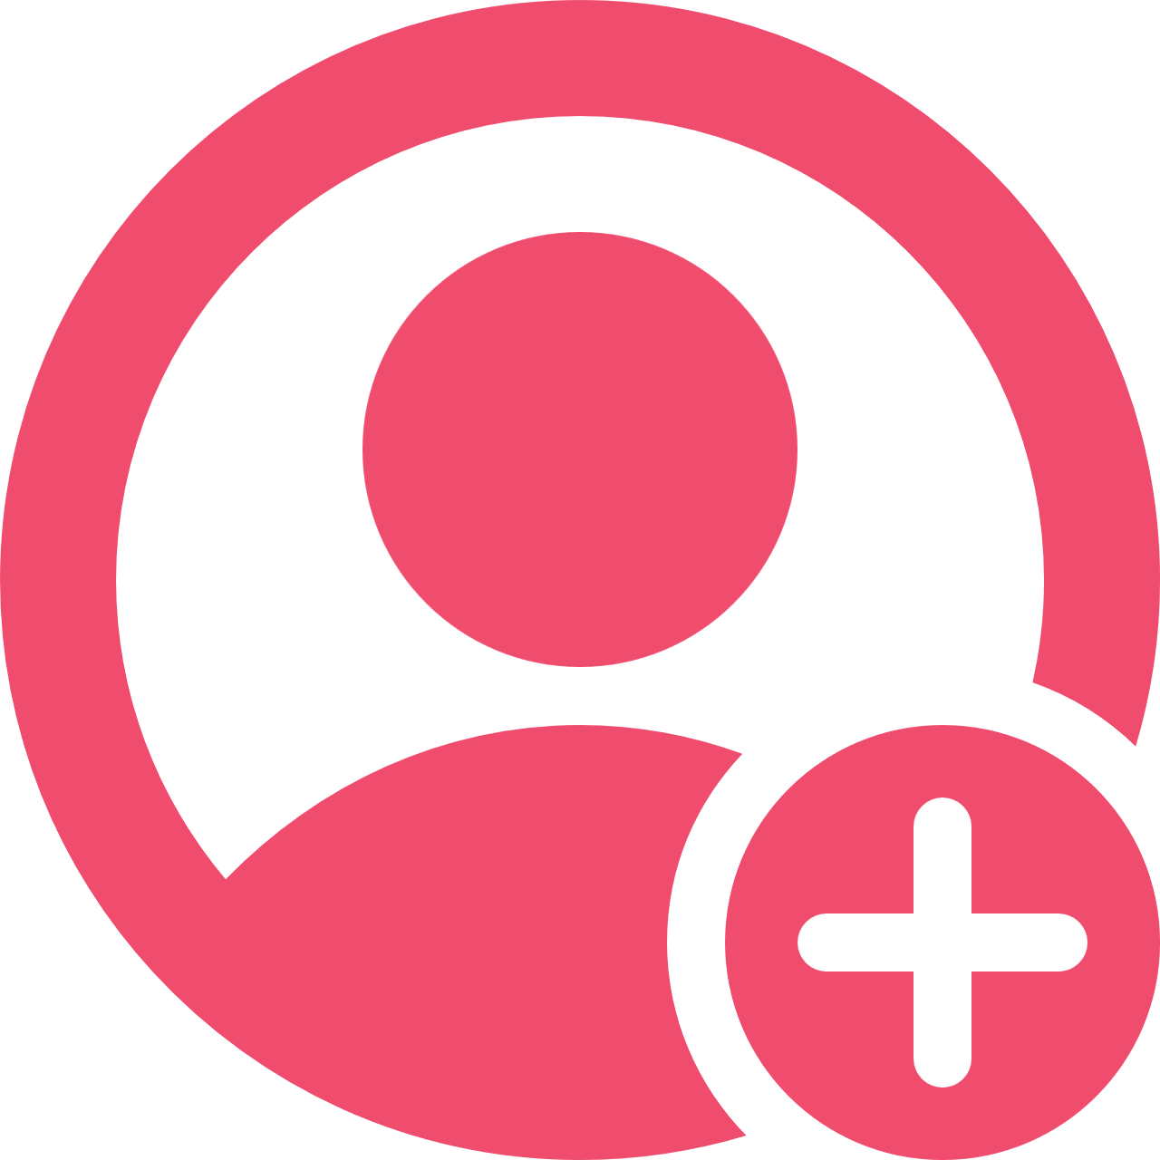

The main things:
- Proven experience in digital product ownership or platform delivery within a complex, customer-facing organisation
- Strong understanding of agile delivery, release management, and coordinating UAT or pre-release testing cycles
- Familiarity with Salesforce or a comparable CRM platform – case management design, configuration, access models and technical governance
- Experience designing or redesigning customer-facing processes and forms, with an understanding of how capture design affects downstream data quality
- Experience implementing or managing a knowledge base, content standards or a structured content lifecycle
- Data literacy – able to build, interpret and report adoption metrics, delivery KPIs and benefit realisation to senior stakeholders
- Confidence holding a testing and quality standard under delivery pressure, without becoming either a blocker or a rubber stamp
- Experience managing, coaching or mentoring junior colleagues or apprentices
- Strong stakeholder management and communication skills, comfortable operating in a small, hands-on team
- An understanding of accessibility standards (WCAG 2.1 AA) and digital inclusion, and how these apply to customer-facing channels
- Eagerness to develop own skills and adapt to change.
- Personal values and approach that align with YH’s values
- Ability to work flexibly in line with Hub, Home and Roam principles.
- An understanding of Equality, Diversity and Inclusivity and how this is applied through our service to customers and colleagues.

It would be a bonus if you have:
- Experience with AI or automation tooling in a customer experience or contact centre context
- Experience working within a housing, public sector, or regulated service environment
- Experience with service design or journey mapping techniques
- Experience of standard operating procedures and Customer operations

Our Yorkshire Housing values | 

What are they?
Our values describe what matters most to us, and what our colleagues should expect
from each other. We’re all expected to show how we support and live up to these values
in our work.

Our colleagues are amazing
We want colleagues to feel free to be themselves, which means we all share responsibility for promoting a culture of equality, diversity and inclusion. We’re also each accountable for our own health and safety by following our policies and completing any training needed for our roles. Our colleagues are amazing, and the diverse skills and abilities they bring to work every day are what make Yorkshire Housing such a special place to be. You spend a lot of your waking hours at work, so we’re committed to giving you a workplace where you can truly be yourself, feel valued, and have opportunities to progress and develop.

Create trust |  |  | Be curious | 
- Do the right thing, not the easy thing  - Be honest and open  - Do what you say. |  |  | - Think differently  - Ask questions  - Keep learning.

Make it happen |  |  | Achieve impact | 
- Own it  - Do it  - Be empowered |  |  | - Do things that matter  - Deliver results  - Show pride and passion.

Have fun | 
- Enjoy work
- Be yourself
- Stay connected.

