Team Leader (Commercial and Contracts)

March 2026

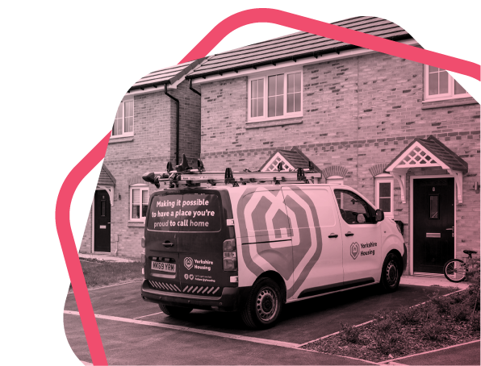
Key information about the role | 

 |  | Team Leader (Commercial and Contracts)
 |  | Reports to: Senior Team Leader |  |  |  | Leader of others:  Yes
 |  | Business area:  Homes |  |  |  | Contract type:  Agile
 |  | Budget holder:  No |  |  |  | DBS check required:  Yes

 | About the role

Role purpose

Be responsible for the effective supervision, delivery, quality control and operational performance of contractors carrying out the delivery of all aspects of commercial gas repair, servicing and installation for Yorkshire Housing customers (including air source heat pumps and other renewable heating technology).

You must have strong technical knowledge and hands-on experience working on commercial gas installations, appliances, and heating systems. You must also hold current ACS domestic and commercial gas qualifications, including core gas safety, heating and hot water, and any relevant appliance specific competencies required for domestic properties and plant rooms/commercial systems.

Have the experience to ensure that all work undertaken is compliant with all statutory regulations and safe methods of working; internal processes & procedures are delivered stringently within performance targets.

Effectively work as part of the Gas & Mechanical team to ensure resources are effectively utilised, and that service and organisational priorities are responded to using innovative, cost-effective solutions.

‘Live and breathe’ our values and you will be a key contact for both the business and our customers. This role is key in Yorkshire Housing’s front line delivery service in ensuring that the team delivers an efficient service to the high levels of customer satisfaction.

Have a great understanding of operational values and cost efficiency enabling you to be innovative and proactive in ensuring that operational decisions maximise value for Yorkshire Housing and our customers having the ability to provide clear direction, effective supervision, leadership and support to staff; develop a leadership style and culture which encourages and motivates staff to enable the provision of excellent services.

Here’s some of the things you’ll be doing | 

We’re Yorkshire by name and by nature. And we make it possible for people to have a place they’re proud to call home, whether that’s to rent or to buy. It’s our people that make that happen, and here’s how you’ll be supporting:

Key responsibilities:
- Proactively handle customer complaints in line with the association’s procedures while providing the highest level of service.
- Assist/ lead in carrying out and coordinating/implementing all quality audit checks as required.
- Deliver regular updates to the team leading and delivering contractor review meetings.
- To advise management and operatives on issues/updates relating to gas safety.
- Responsible for ensuring that all gas and mechanical work is delivered in full compliance with statutory regulations, approved safe systems of work, and internal policies and procedures. You will oversee the completion of tasks to the highest standards, maintaining strong performance, rigorous safety practices, quality workmanship, cost efficiency, and exceptional customer satisfaction.
- Oversee day-to-day operations of contractors.
- Set and measure clear goals and expectations for contractors.
- Monitor contractor performance and report on KPI’s.
- Ensure contractors training and qualifications are correct and up to date, provide coaching and development.
- Listen to contractors' feedback and resolve any issues or conflicts.
- Work with senior management and proactively engage with stakeholders across the business to resolve issues and problem solve.
- Assist and support the Service Manager and Senior Team Leaders in resource planning and to deputise when required.
- Assist the Service Manager and Senior Team Leader in the day-to-day budgetary control and financial profiling of the section.
- Work as part of the team, liaising with other trades, colleagues and clients as necessary.
- Ensure that key documentation and systems are completed on time and accurately.
- Deliver a high level of service while also ensuring operational decisions deliver a service with value.
- Innovate and work as part of a management team to continuously improve the services we deliver.
- Manage and engage with sub-contractors, suppliers and third parties.
- Be included in out-of-hour manager escalation on a rota basis.

 | As you can imagine, the above might not be all you’ll be responsible for in role so you might be asked to take on some other key responsibilities if they’re suitable for your role.

So, what will you bring to the role? | 

The main things:
- COCN1/CODNCO1
- TPCP1/TPCP1A
- CIGA1
- CCN1
- CENWAT
- CKR1
- HTR1
- Experience of building internal and external relationships and strategic partnerships.
- Experience and technical knowledge in relation to commercial Gas and Mechanical Services.
- Demonstrate a thorough knowledge of current Health and Safety best practice.
- Previous experience dealing with customers and understanding how to deliver outstanding customer service.
- Excellent communication and leadership skills, ability to influence colleagues at all levels.
- Previous experience coaching and auditing in quality and complying with relevant standards and can communicate technical details.
- Decision making skills, prioritising our customers and promoting efficiency and value for money.
- Good IT skills, including Microsoft office applications, Servicesoft, smart devices and YH housing management system
- Organisational, prioritisation and time management skills with an ability to work calm under pressure
- Ability to work as a team player with all levels of colleagues and different areas of the business.
- Ability to work using your own initiative, manage your own time and be able to prioritise tasks.
- Demonstrate excellent communication and interpersonal skills.
- Appetite for transformational change and continuous improvement
- Eagerness to develop own skills and adapt to change.
- Personal values and approach that align with YH’s values.
- Ability to work flexibly in line with Hub, Home and Roam principles.
- An understanding of Equality, Diversity and Inclusivity and how this is applied through our service to customers and colleagues.
- Experience with renewable technologies is desirable but not essential.
- You must have the ability to work outside normal office hours on an occasional basis and a willingness to respond to occasional out of hours emergency calls.
- A full UK Driving License and daily access to a car.
Our Yorkshire Housing values | 

What are they?
Our values describe what matters most to us, and what our colleagues should expect
from each other. We’re all expected to show how we support and live up to these values
in our work.

Our colleagues are amazing
We want colleagues to feel free to be themselves, which means we all share responsibility for promoting a culture of equality, diversity and inclusion. We’re also each accountable for our own health and safety by following our policies and completing any training needed for our roles. Our colleagues are amazing, and the diverse skills and abilities they bring to work every day are what make Yorkshire Housing such a special place to be. You spend a lot of your waking hours at work, so we’re committed to giving you a workplace where you can truly be yourself, feel valued, and have opportunities to progress and develop.

Create trust |  |  | Be curious | 
- Do the right thing, not the easy thing  - Be honest and open  - Do what you say. |  |  | - Think differently  - Ask questions  - Keep learning.

Make it happen |  |  | Achieve impact | 
- Own it  - Do it  - Be empowered |  |  | - Do things that matter  - Deliver results  - Show pride and passion.

Have fun | 
- Enjoy work
- Be yourself
- Stay connected.

